South Dakota Department of Agriculture and Natural Resources 523 E Capitol
Pierre, SD 57501

South Dakota’s Volkswagen
Class 4-8 Local Freight Truck Rebate Program

Guidelines and Applications Rounds Eight and Nine
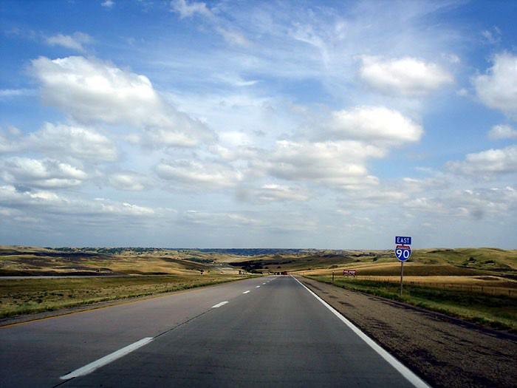

Application Deadlines:
January 27, 2023 – 5:00 PM &
June 23, 2023 – 5:00 PM
This program is funded through the South Dakota Volkswagen (VW) Environmental Mitigation Trust

Section 1 – Introduction
The primary goal of South Dakota’s VW Environmental Mitigation Trust Program is to facilitate the improvement and protection of the ambient air quality throughout South Dakota. The South Dakota Department of Agriculture and Natural Resources (DANR) administers the program. The program provides rebates to help purchase new class 4-8 local freight trucks that replace older in-use higher emitting diesel trucks to reduce diesel particulate matter and smog-forming emissions.

Program information will be posted on the VW Mitigation Trust Program Truck website at https://danr.sd.gov/Environment/AirQuality/VolkswagenTrust/VWTrucks.aspx. For additional information, please contact: Barb Regynski at 1-800-GET-DENR (1-800-438-3367) or barb.regynski@state.sd.us.

Section 2 – Background
In 2016, EPA and California filed a lawsuit against Volkswagen for installing a system that allowed nitrogen oxide pollution, also referred to as NOx, to exceed levels allowed by the Clean Air Act. As part of the court settlement, Volkswagen funded an Environmental Mitigation Trust to be used to offset the excess pollution emitted by the non-compliant vehicles. South Dakota’s Allocation from the trust is
$8,125,000.

Section 3 - Eligible Participants
South Dakota state and local governmental agencies are eligible to participate.

Section 4 - Eligible Projects
The eligibility criteria for existing trucks to be replaced and receive a rebate are as follows:

- Class 4-8 diesel-powered local freight trucks (Gross Vehicle Weight Rating 14,001 pounds and greater) with engine model years 1992 through 2009. The replacement truck must be of the same type and class.

- The truck being replaced must be scrapped or rendered permanently disabled within ninety (90) days of the replacement. Evidence of appropriate disposal (including colored digital photos of the engine tag showing serial number, engine family number, and engine model year, vehicle identification number (VIN), and of the destroyed engine block and cut frame rails or other structural components) is required for rebate to be made. Drilling a three inch hole in the engine block and disabling the chassis is the preferred scrapping method. Equipment and vehicle components that are not part of the engine or chassis may be salvaged from the unit being replaced (e.g. plow blades, shovels, seats, tires, etc.). If scrapped or salvaged vehicles/parts are sold, the income may be used to meet the cost-sharing or matching requirement of the award, including any mandatory or voluntary cost-share. Therefore, the amount of the award remains the same.

The eligibility criteria for new replacement trucks are as follows:

- Diesel, alternate fueled, or all-electric class 4-8 local freight trucks (Gross Vehicle Weight Rating 14,001 pounds and greater) engine model year one year prior to the replacement or newer. The replacement must be of the same type and class.

- Total rebate per replacement will be up to 35% of the purchase price of a truck with an engine certified to meet EPA emission standards, 45% of the purchase price of a truck with an engine certified to meet CARB’s Low-NOx standards, or 55% of the purchase price of an all-electric truck.

- The applicant should receive the new truck by June 1, 2024 for round eight and by December 1, 2024 for round nine.

Section 5 – Funding Amounts
During rounds eight and nine there will be approximately $1,000,000 of Volkswagen trust funds available for replacing trucks. Approximately half will be available for round eight and any funds remaining will carry over to round nine.

Section 6 – Project Awards
Ranking will be based on a combination of the age of the diesel engine being replaced, cost of the replacement vehicle, and nitrogen oxide reductions. To ensure improvement and protection of the ambient air quality throughout South Dakota is achieved, each applicant will receive one replacement vehicle before an applicant receives a second replacement vehicle, and so on.

Selected applicants will enter into a written agreement with DANR and will submit a copy of their purchase order. Rebates will be issued upon submittal of a Request for Reimbursement Form, evidence of final vehicle purchase price, a Certificate of Disposal Form, photographic evidence of disposal, Completed W-9 Form, and if requesting the 45% rebate, a copy of the engine certificate showing it meets CARB’s Low-NOx Standards.

Section 7 – Tentative Schedule
Round Eight
Date | Activity
January 3, 2023 | Call for Round Eight Projects Opens
January 27, 2023 | Call for Round Eight Projects Deadline
January 30, 2023 –  February 10, 2023 | Evaluate & Select Round Eight Projects
February 15, 2023 | Post Round Eight Selected Projects. Email rebate agreements to highest ranking applicants.
February 2023 –  April 2023 | Recipients will order Round Eight trucks and email DANR copies of purchase orders
June 30, 2024 | Deadline for all invoices and paperwork for Round Eight  to be submitted to DANR

Round Nine
Date | Activity
June 1, 2023 | Call for Round Nine Projects Opens
June 23, 2023 | Call for Round Nine Projects Deadline
June 26, 2023 –  July 7, 2023 | Evaluate & Select Round Nine Projects
July 12, 2023 | Post Round Nine Selected Projects. Email rebate agreements to highest ranking applicants.
July 2023 –  September 2023 | Recipients will order Round Nine trucks and email DANR copies of purchase orders
December 31, 2024 | Deadline for all invoices and paperwork for Round  Nine to be submitted to DANR

Section 8 – Program Application Process
The application and program participation process is as follows:
- Program applications are attached to this document and are also available from the website at https://danr.sd.gov/Environment/AirQuality/VolkswagenTrust/VWTrucks.as px .

- Applications must be submitted to DANR by 5:00 PM, January 27, 2023 and/or 5:00 PM, June 23, 2023. Applications are to be submitted by email to barb.regynski@state.sd.us or by mail to:
VW Rebate Program
SD DANR – AQ Program 523 E Capitol
Pierre, SD 57501

- DANR will evaluate applications.

- DANR will post selection list.

- Selected applicants will be emailed rebate agreements.

Section 9 – Program Requirements
Successful project applicants must enter into an agreement with DANR setting forth specific performance criteria to ensure compliance with statutory and audit requirements. Agreement preparation will begin immediately upon DANR selection of a project. The agreement will include further details on complying with program requirements. All services or work carried out under an agreement awarded as a result of this call for projects must be completed within the scope, time frames, and funding limitations specified by the agreement. Upon signature and execution of the agreement by DANR, a copy of the executed agreement will be returned to the applicant, at which time the project will be considered awarded.

Replacement Truck Requirements

- Ordering of new trucks may not occur prior to both parties signing the agreement. Rebates will be made on a reimbursement basis for eligible expenses incurred and paid by the recipient. A cost may not be considered incurred until the replacement truck has been received and accepted by the recipient.

- The applicant must provide DANR with a copy of the Division of Motor Vehicles registration or title for the truck being replaced.

- The applicant must submit a copy of the Purchase Order to DANR.

- The applicant must ensure that the replaced truck is permanently disabled or scrapped and maintain documentation on how the replaced truck was permanently disabled or scrapped.

- Applicant submits a Request for Reimbursement Form, evidence of final truck purchase price, Certificate of Disposal Form, photographic evidence of disposal, completed W-9 Form, and if requesting the 45% rebate, a copy of the engine certificate showing it meets CARB’s Low-NOx Standards. DANR will review the information for compliance with all grant requirements.

- Rebate will be issued upon verification (documentation and/or DANR staff site visit).

- The applicant agrees that program criteria and requirements may be reviewed, as new information becomes available, and can be revised at the discretion of DANR.

- DANR maintains the right to monitor the project periodically.

- The applicant must maintain ownership of the replacement truck for three years after receipt of the rebate.

Section 10 - Verification Procedures
Any applicant that receives VW Truck Replacement Rebate Program funds may be subject to verification of each program or project funded. The verification may be conducted by staff from DANR. Rebate documentation, records, and referenced materials must be available for review during monitoring visits.

Upon the completion of verification, DANR will determine if the funds were used for the approved project and make the verification available to the applicant and to the public upon request.

If DANR determines that the funds were expended in a manner contrary to law or not in accordance with provisions, DANR will notify the applicant of the determination, and may, at its discretion, seek re-payment of funds misappropriated, spent for non-eligible activities, or otherwise inappropriately expended.

APPLICATION PACKET CHECKLIST TRUCK REPLACEMENT

A complete application packet includes the following items:

  - Completed Application Form.

  - Copy of Department of Motor Vehicles registration or title for the truck to be replaced.

  - Dated and itemized dealer quote for replacement truck.
Applications must be submitted to DANR by 5:00 PM, January 27, 2023 and/or 5:00 PM, June 23, 2023. Applications are to be submitted by email to barb.regynski@state.sd.us or by mail to:
VW Rebate Program
SD DANR – AQ Program 523 E Capitol
Pierre, SD 57501

TRUCK REPLACEMENT APPLICATION
I. APPLICANT INFORMATION
1 | a. Applicant Name: |  |  |  |  |  |  | b. DUNS Number:
2 | Applicant Address:
3 | a. City: |  |  |  |  | b. State: |  | c. Zip + 4:
4 | a. Contact Name: |  |  |  |  | b. Contact Title:
5 | a. Contact Phone: |  |  |  |  | b. Contact Fax:
6 | Contact Email:
II. EXISTING TRUCK INFORMATION:
1 | Truck Storage Address:
2 | a. City: |  | b. County: |  |  |  | c. Zip Code:
3 | Truck Type/Use (e.g. snow plow, dump truck):
4 | Class: 4, | 5, 6, 7, 8
5 | Short Haul-Single Unit, Short Haul-Combo, Long Haul-Single Unit, Long Haul-Combo, Refuse Hauler (short </= 200 miles, long > 200 miles, single=truck on single frame, combo=tractor with at least 1 trailer)
6 | a. Truck Manufacturer: |  |  | a. Truck Model: |  |  |  | b. Truck Model Year:
7 | Type of Fuel: Diesel |  | Estimated Annual Fuel Usage for this Truck (gallons):
8 | a. Cumulative Mileage: |  | b. Estimated Annual Mileage: |  |  |  |  | c. Annual Idling Hours:
9 | Vehicle Identification Number (VIN):
10 | a. Engine Manufacturer: |  |  | b. Engine Model: |  |  |  | c. Engine Model Year:
11 | Engine Serial Number:
12 | Estimated remaining life (years):
III. NEW REPLACEMENT TRUCK INFORMATION
1 | Truck Type/Use (e.g. plow truck, dump truck, refuse truck):
 | Class: 4, | 5, 6, 7, 8
2 | a. Truck Manufacturer: |  |  |  | a. Truck Model: |  |  |  | b. Truck Model Year:
3 | Type of Fuel: | ULSD, CNG, LNG, LPG/Propane, Gasoline, |  |  |  |  |  |  |  | Electric, or Other
4 | Rebate: 35%, | 45% if certified to meet CARB’s Low-NOx Standards, or |  |  |  |  |  |  |  | 55% if an all-electric
6 | a. Price of New Truck:
7 | a. Estimated Purchase Order Date: |  |  |  |  | b. Estimated Date of Truck Delivery:
8 | a. Engine Manufacturer: |  |  | b. Engine Model: |  |  | c. Engine Model Year:
IV. SCRAPPING COMPANY/DISMANTLER INFORMATION
1 | Describe Method of Disposal of Truck:
2 | Scrapping Company/Dismantler Name:
3 | Contact Name:
4 | Address:
5 | a. City: |  |  | b. State: |  |  | c. Zip Code:
6 | a. Phone: |  |  | b. Fax:
7 | Email:

TRUCK REPLACEMENT APPLICATION
V. TRUCK MANUFACTURER/DEALER INFORMATION
1 | Truck Manufacturer/Dealer:
2 | Contact Name:
3 | Address:
4 | a. City: | b. State: | c. Zip Code:
5 | a. Phone: | b. Fax:
6 | Email:
VI. APPLICANT’S CERTIFICATION
I certify that to the best of my knowledge the information contained in this application and in the supplemental material is correct and complete. I certify that the funding requested satisfies the eligibility requirements for this Program as represented in the Program Description and related materials. I certify that I understand that the funding under this Program is subject to restrictions and other conditions listed in the Program Description.
 | The applicant will use the funding under this Program for the specific purposes defined in the Program Description.
 | The applicant has received approval to apply and make use of the funding under this program.
 | The applicant is not currently debarred or suspended from receiving federal funding.
 | The applicant agrees to complete scrappage of the truck being replaced.
 | The applicant certifies that all vendors will be selected in accordance with contracting laws.
I authorize DANR to make any necessary inquiries to verify the information that I have presented. I acknowledge that the information in this application is not confidential and may be released as required by the Program.
Printed Name of Responsible Party: |  |  | Title:
Signature of Responsible Party: |  |  | Date:

Applications are to be submitted by email to barb.regynski@state.sd.us or by mail to: VW Rebate Program
SD DANR – AQ Program 523 E Capitol
Pierre, SD 57501

Request for Reimbursement Form

Name of Applicant:
Date new truck was delivered:

Engine Model Year of New Truck:

Instructions: Fill in the information below to summarize the Reimbursement Request.

Reimbursement Summary
Final Purchase Price of Truck | $
Rebate Amount (not to exceed awarded amount) = Final Purchase Price X percentage from award | $
*Program Income from Salvage/Scrappage | $
*If scrapped or salvaged engines/vehicles are to be sold, program income requirements apply. Program income may be used to meet the cost-sharing or matching requirement of the award, including any mandatory or voluntary cost-share. The amount of the award remains the same.

- Please attach a completed IRS W-9 Form
- Please attach evidence of final truck purchase price such as a copy of the dealer invoice, receipt, or canceled check
- Please attach Certificate of Disposal and photos verifying disposal
- if requesting the 45% rebate, please attach a copy of the engine certificate showing it meets CARB’s Low-NOx Standards.

Requests are to be submitted by email to barb.regynski@state.sd.us or by mail to: VW Rebate Program
SD DANR – AQ Program 523 E Capitol
Pierre, SD 57501

Certificate of Disposal Form

Applicant Name: Old Truck/Chassis Information
Make: |  | Vehicle ID Number:
Model: |  | Odometer Reading: | miles
Year:

Old Engine Information
Make: |  | Horsepower:
Model: |  | ID or Serial No.:
Year:

Name of Dismantler:

Address of Dismantler: Signature of Dismantler: Date Truck Disabled:

Applicant Representative:

Statement: I certify that within 90 days of replacement, the old engine and chassis have been permanently disabled. Disabling the engine consists of cutting or punching a three inch by three inch (3" x 3") hole in the engine block. Disabling the chassis consists of cutting completely through the frame/frame rails on each side of the vehicle/equipment at a point located between the front and rear axles. Photos of the disabled engine/chassis that are required pursuant to the Terms and Conditions of the award agreement are attached to this Certificate of Disposal.

Representative Name:

Representative Signature: Date:

Note: Documentation must include colored JPEG images of the following, with corresponding file names:

1) Side profile of vehicle | 3) Engine label | 5) Engine block, prior to hole | 7) Others, as needed
2) VIN | 4) Chassis rail cut in half | 6) Engine block, after hole

Examples of Vehicle Disposal Pictures

Photo #1: Side profile of vehicle being scrapped
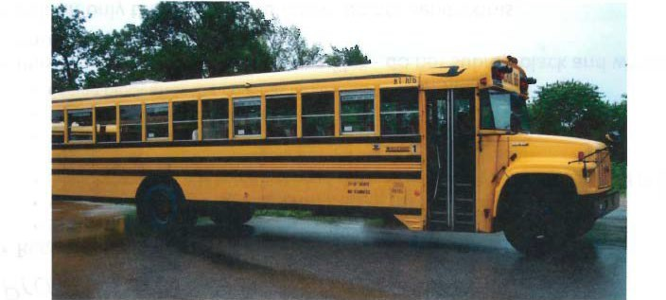

Photo #2: VIN of the vehicle being scrapped
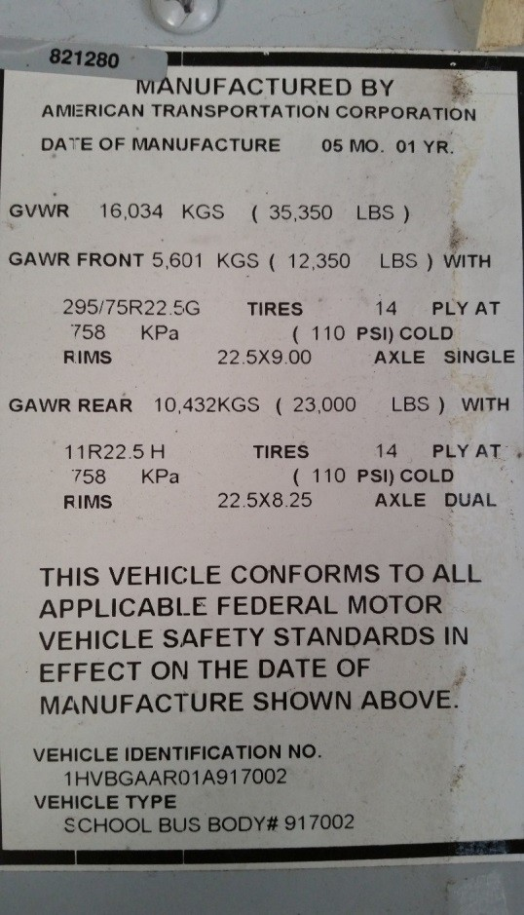

Photo #3: Engine tag with engine serial number and EPA engine family name

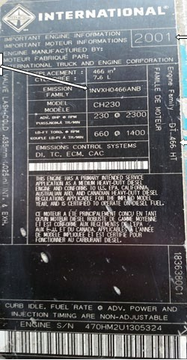

Photo #4: Chassis rail cut in half
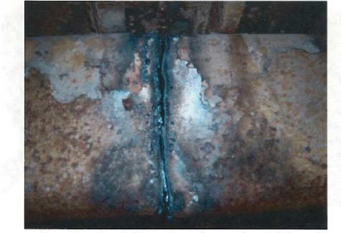

Photo #5: Engine block prior to hole being drilled
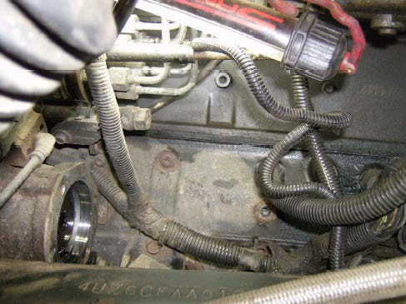

Photo #6: Engine block after hole has been drilled
