Examples of Vehicle Disposal Pictures

Photo #1: Side profile of vehicle being scrapped
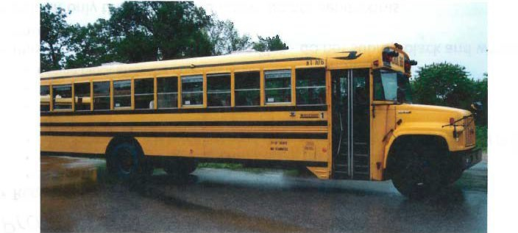

Photo #2: VIN of the vehicle being scrapped
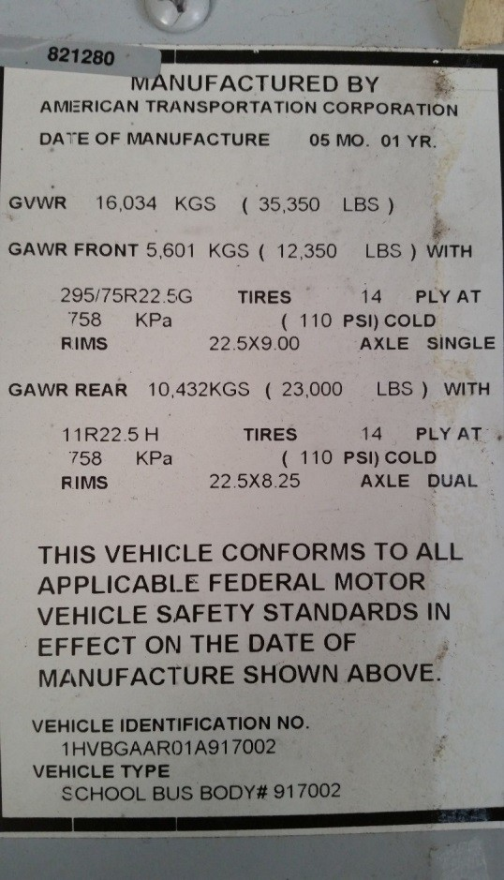

Photo #3: Engine tag with engine serial number and EPA engine family name

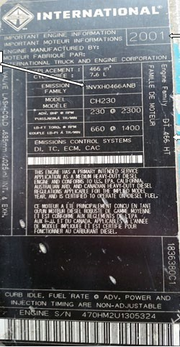

Photo #4: Chassis rail cut in half
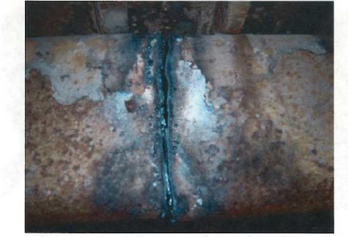

Photo #5: Engine block prior to hole being drilled
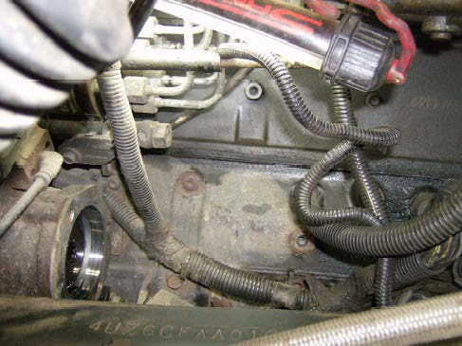

Photo #6: Engine block after hole has been drilled
